Hello all,

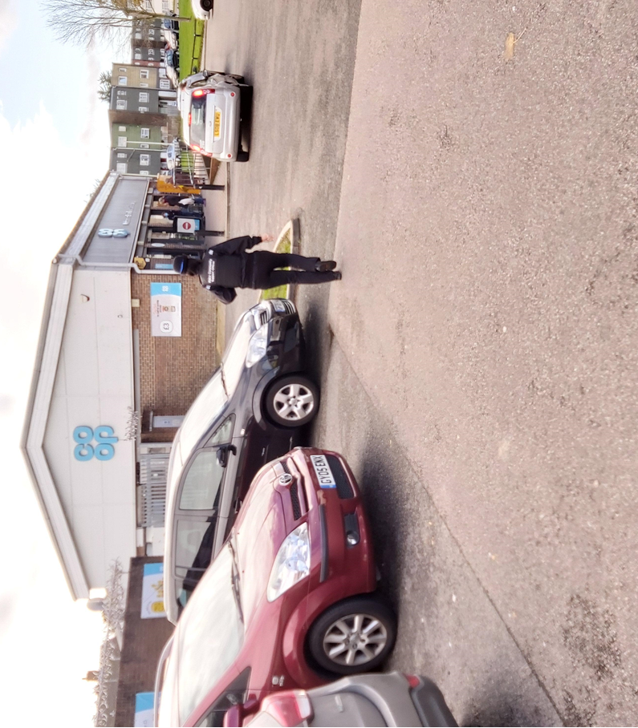**MAY 2021** REPORT for Stanhope, Norman and Beaver Wards from PCSO Nikki Potter.

In my role as a PCSO I am either in the area either on foot, bike or in a police vehicle, engaging with the community and visiting those who need my help, assistance and reassurance.

The month of May has seen more Covid changes come into place with Shops, Cafes and Pubs reopening.

This will see life getting back to normal but please follow all Government guidelines still as it is essential in combatting this virus. A face mask is still needed when entering shops and public house, restaurants, coffee shops & public transport. More and more have now received their 2nd Vaccination which is proving to bring the number cases down.

The new knife bin has now been installed in Stanhope it can be located outside the Community Centre/Library. Please pass this on to the Community for awareness.

The number of catapult incidents in Stanhope and South Ashford have decreased this month but I would still urge if you see any incident of this type to report to the Police, this type of incident is totally un acceptable and the offenders need to be apprehended.

I am pleased to see that The Community Hub is once again open they can cater for up to 6 people from 3 different households and also have outdoor space, this will be a really valuable support to the Community and I look forward to popping in to see how this is going.

**Public Meetings**

All public meetings at this time are cancelled due to Covid-19. A live chat line is also another option to report to Police please look on the Police website for dates this will happen on your wards.

**Please always check the Kent Police website for any digital meetings that may occur in your area**

**Local Incidents**

**Monkton Close – youths seen with catapults**

**Otterden Close - youths seen letting of fireworks**

**The Close Stanhope- Burglary from Garage**

**Boxley – Vehicle crime scratches on side doors**

**Boxley – Burglary from a shed**

**Knoll Lane – nuisance bike riding around the green area no helmet, making noise**

**WaterMead Close – attempted shed break-in**

**St. Francis Court – Wood thrown at a property and front door glued**

**Lower Denmark Rd – report of youths throwing rubbish around and being abusive**

[](https://www.google.co.uk/url?sa=i&url=https%3A%2F%2Fwww.politico.eu%2Farticle%2Fe-scooters-start-to-run-out-of-juice-in-europe%2F&psig=AOvVaw0OYODYpxe40ky55L24143w&ust=1605873941808000&source=images&cd=vfe&ved=0CAIQjRxqFwoTCJjG3OHIju0CFQAAAAAdAAAAABAJ)

# **E-scooters – know the law**

Although e-scooters can be great fun, it’s against the law to ride one on a public road, cycle lane or pavement.

**What you need to know**

e-scooters are classed as Personal Light Electric Vehicles (PLEVs), which means t­hey are treated as motor vehicles and subject to the same legal requirements, such as driving licence, insurance, number plates, lighting, road tax, crash helmets etc. **Without these, e-scooters cannot be used legally on the road**.

The Government is currently trailing the use of approved rental e-scooters as environmentally friendly modes of transport in some specific locations in the UK.

For the rest of the country, under current law, e-scooters can only be used on private land.

**What should I do now?**

It’s our priority to keep you and other road users safe.

We are obliged to act against anyone who is caught repeatedly using an e-scooter illegally or in a way that causes a nuisance to others. In these circumstances we have the power to seize the e-scooter under Section 59 of the Police Reform Act/165 of the Road Traffic Act – and we’d really prefer not to.

From now on, please make sure you **only use your e-scooter on private land**.

For more information about powered transporters and the law, visit [**www.gov.uk**](http://www.gov.uk)

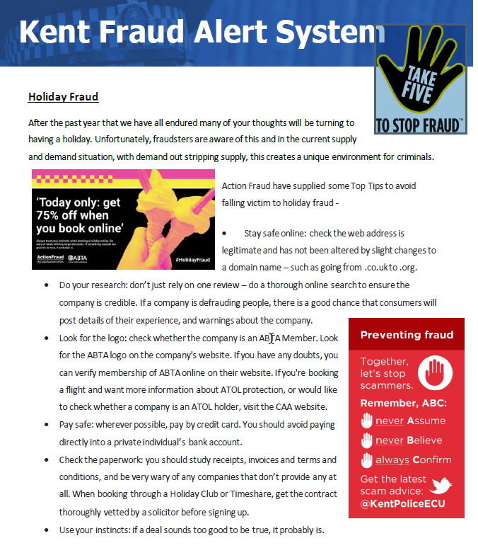

Kent Fraud Alert System

**#MONTHLYTWEETS**

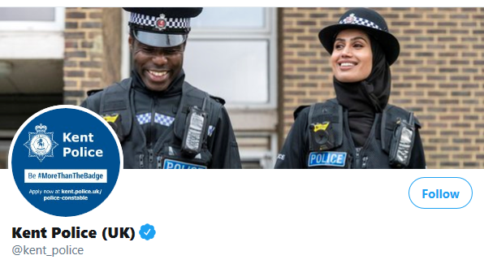

**#MONTHLYTWEETS**

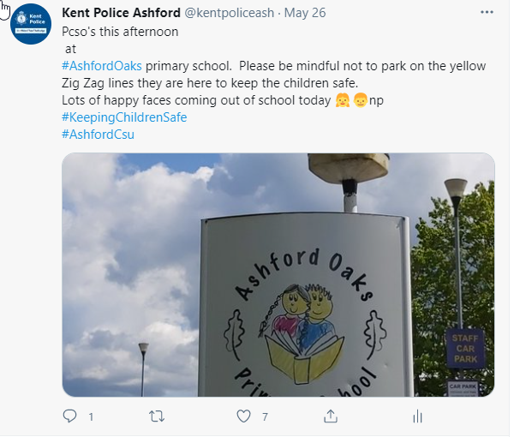

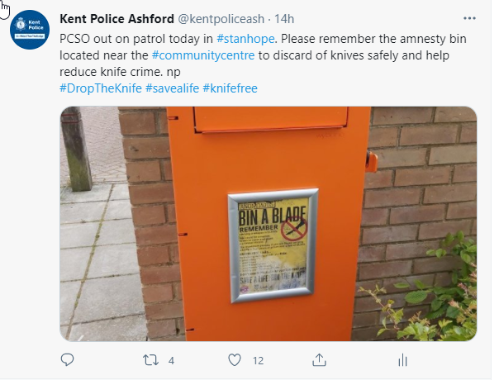

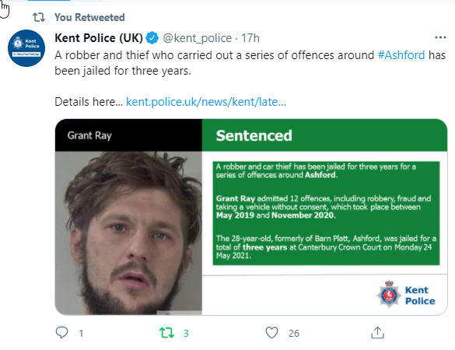

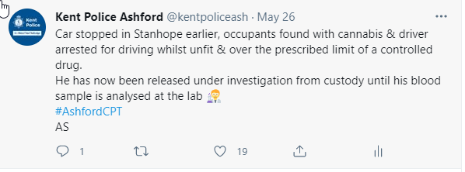

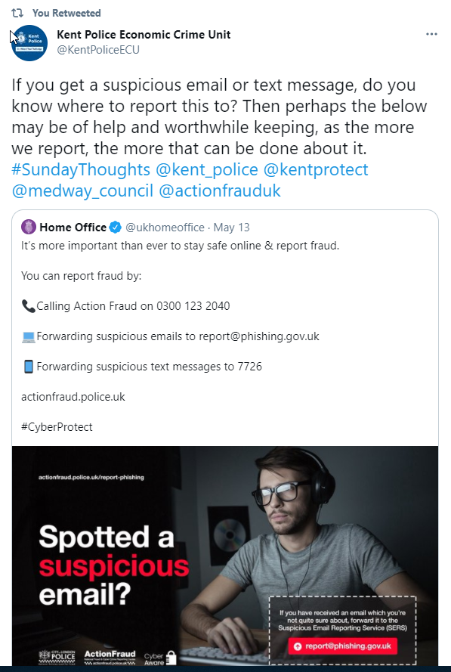

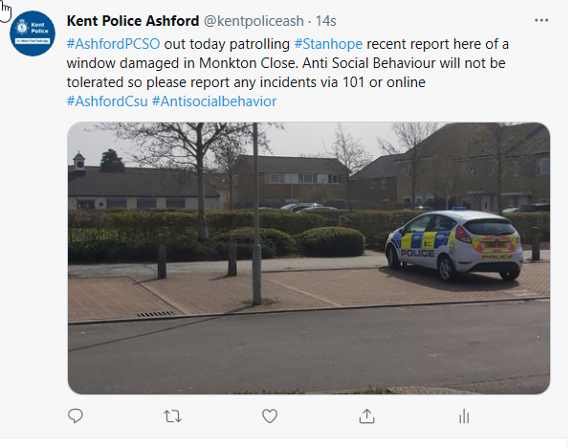

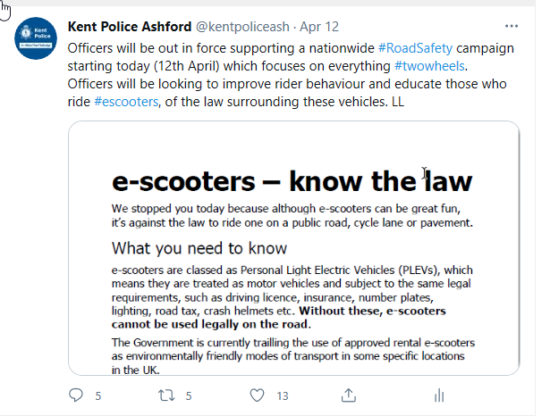

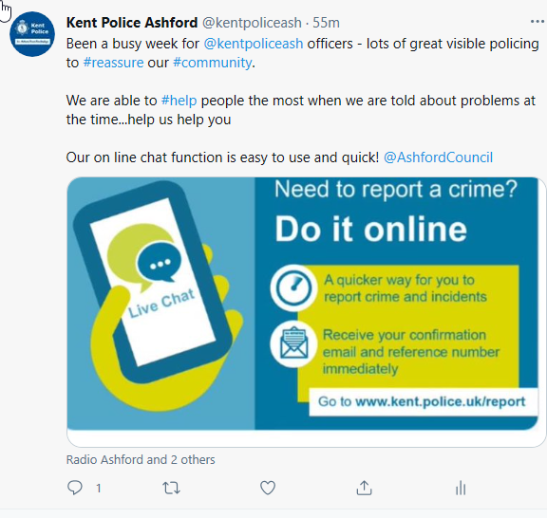

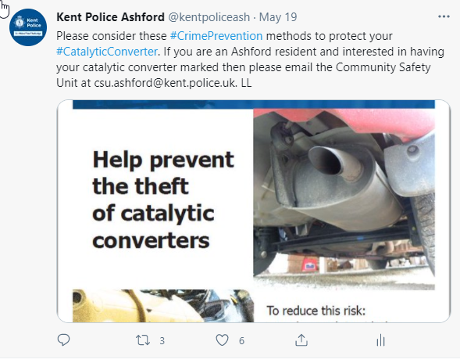



You can find more information via Twitter follow Kent police **#ashfordCsu**

**Roads Policing Unit supports safety campaign week**

Officers from Kent Police’s Roads Policing Unit will be supporting a national week promoting safe driving on low speed roads.

The Global Road Safety Week runs from Monday 17 May 2021 until Sunday 23 May 2021 and advocates lower speed limits in cities worldwide in places where people mix with traffic.

Statistics show that pedestrians, cyclists, motorcyclists and other powered two-wheeler users are consistently overrepresented in all killed and seriously injured categories where collisions are most likely to occur on low speed, local roads.

In support of the campaign, officers from Kent Police will concentrate on hotspots and peak times for collisions on roads with a 30mph speed limit.

Inspector Thomas Pooley said: ‘Speeding is one of the ‘fatal four’ causes of collisions targeted by roads policing patrols on a daily basis in Kent. The others being mobile phone use, drink or drugs and seatbelt use.

‘Speed limits are in place for a reason and though you may wish to reach your destination quickly just a small reduction in your speed can reduce the likelihood of a collision.

‘This week offers us an opportunity to keep local communities safe by tackling neighbourhood speeding and will include high visibility patrolling and static speed checks on key hotspot areas within neighbourhoods on 30mph roads.’

‘Motorists caught speeding will be issued with a Traffic Offence Report (TOR) and face a fine, points on their licence or even court action. Some drivers can opt to take part in a speed awareness course.’



**Driver who rammed police car in Ashford is jailed**

A driver who rammed a police car as he tried to get away from officers in Ashford has been jailed.

Cameron Mclaughlin admitted dangerous driving when he appeared before Canterbury Crown Court on Monday 19 April 2021.

The 22-year-old, of Hither Field, Charing, was jailed for 18 months at the same court on Friday 7 May and disqualified from driving for three years and seven months.

Officers from Ashford's Local Policing Team saw Mclaughlin’s uninsured Audi A4 driving along Kingsnorth Road, Ashford shortly before 6pm on Sunday 14 March 2021.

They illuminated their patrol car's blue lights to stop him but he drove off at up to 70mph in a 30mph zone.

He continued to drive at above the speed limit in Beaver Lane, Brookfield Road and Chart Road before going around the wrong side of a roundabout.

Officers followed him into Magazine Road, but he reversed his car into their vehicle, before making off again and driving through a set of red traffic lights.

He went through another roundabout on the wrong side before getting out of the car in Heathfield Road. Officers chased him and arrested him.

PC Tania Richardson, Kent Police's investigating officer, said: 'McLaughlin’s reckless driving could very easily have caused a serious collision and harmed other road users.

'He showed no consideration for the welfare of the two officers in the patrol car which he rammed as he tried to evade arrest. Their persistence in tracking and arresting him shows our commitment to bringing to justice dangerous drivers and those who threaten our officers' safety.'

**DOMESTIC ABUSE SUPPORT**

1. Rising Sun Domestic Violence and Abuse Service – Confidential Helpline – 01227 452852. This line is available 9am – 5pm Monday to Friday.
2. Freephone 24-hour National Domestic Violence Helpline run in partnership between Women's Aid and Refuge - 0808 2000 247 or the Men’s' Advice Line on 0808 801 0327.
3. Domestic Abuse Support Services in Kent and Medway - www.domesticabuseservices.org.uk

If you are in danger, please call 999 immediately.

***REPORTING A CRIME***



Please can I remind the community to report crimes or information by the **correct** channels i.e. via 101, [**www.kent.police.uk**](http://www.kent.police.uk) - report a crime or tap the live chat button on this website. Or 999 if an emergency is happening here and now. Crimes are not to be reported to me via e-mail please as I am not always on duty. Police do not monitor community social media pages so if problem areas are not reported to us directly, we will not be aware of them.

**Keep safe Everyone and Stay Alert**



**Nikki Potter PCSO 46056652**

**Community Safety Unit |** **Ashford Police Station | East Division| Please do not use this email to report incidents. For a non-emergency please report online or contact 101 and in case of an emergency call 999.**