[](https://www.google.com/url?sa=i&url=https%3A%2F%2Fwww.ourwatch.org.uk%2Fforce-level-association%2F&psig=AOvVaw35LJXtFmkYa3lknRByrFC_&ust=1583143817507000&source=images&cd=vfe&ved=0CAIQjRxqFwoTCODc9biE-ecCFQAAAAAdAAAAABAE)[](https://www.google.com/url?sa=i&url=https%3A%2F%2Fwww.wildinart.co.uk%2Fsponsors%2Fashford-borough-council%2F&psig=AOvVaw3BzH9hHeye4zJ6FEp4HTGG&ust=1583143932655000&source=images&cd=vfe&ved=0CAIQjRxqFwoTCOCv3O-E-ecCFQAAAAAdAAAAABAE)

***Monthly Newsletter – Victoria ward***

Hello,

This is your monthly newsletter for August 2021 for the Victoria ward from PCSO Oliver Welch.

Crime has remained low in the ward during the month of August with only several crimes of particular interest to bring to your attention. . I must inform you of a burglary that took place within the ward and remind you to ensure that you leave your property safe and secure whenever you are out. There have also been several reports of criminal damage within the ward and again I must remind residents to remain vigilant and report any incidents of crime.

Youths carrying catapults continues to be the top Anti-social behaviour issue in and around the Victoria Park area. I must urge all readers to call police immediately if they witness this and provide as most accurate identification as possible to assist officers in catching the individuals involved.

Crime statistics can be found at: <https://www.police.uk/>

Alternatively, Neighbourhood Watch (NHW) send out regular updates in relation to crimes that have happened in the Ashford area. If you wish to receive these updates directly then please contact Andrew Judd who is the Volunteer and Neighbourhood Watch Liaison Officer. His contact details are as follows:

Tel: 01233 896151

Email: [andrew.judd@kent.police.uk](mailto:andrew.judd@kent.police.uk)

Address: Ashford Police Station,

Tufton Street,

Ashford

TN23 1BT

I have included some examples of good work being carried out across the ward below. We have a very active twitter account that highlights on-going issues within the district and showcases the proactive work that officers carry out on a day to day basis. Should you wish to keep updated follow the account @kentpoliceash

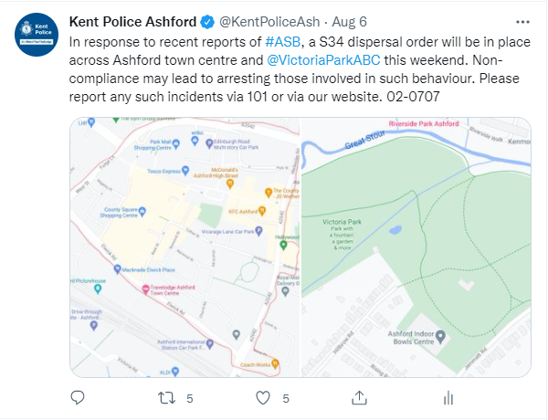

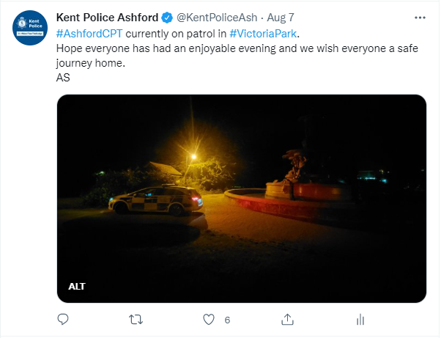



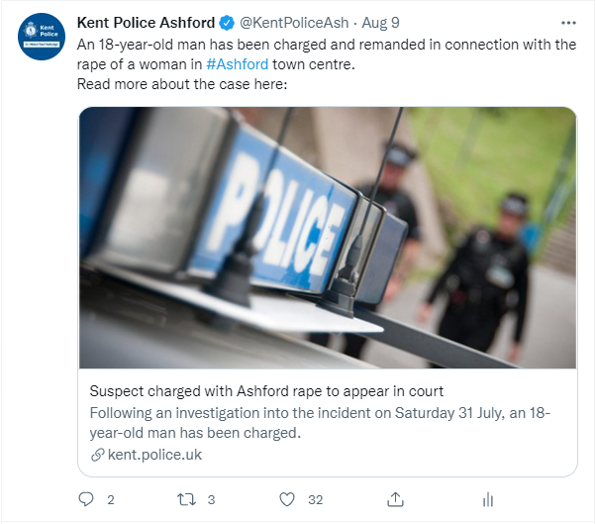

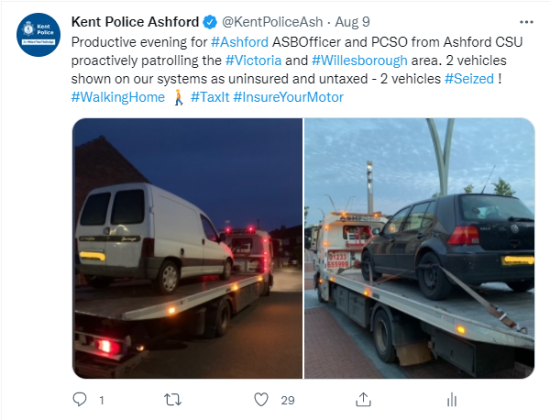

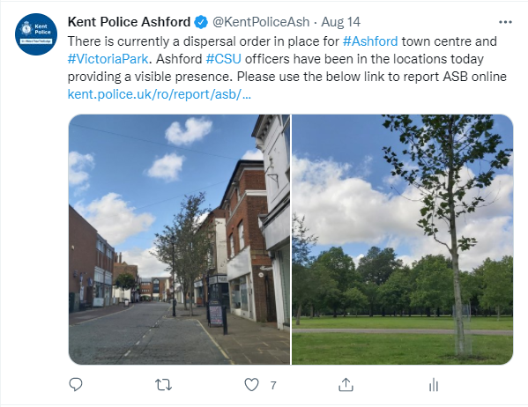

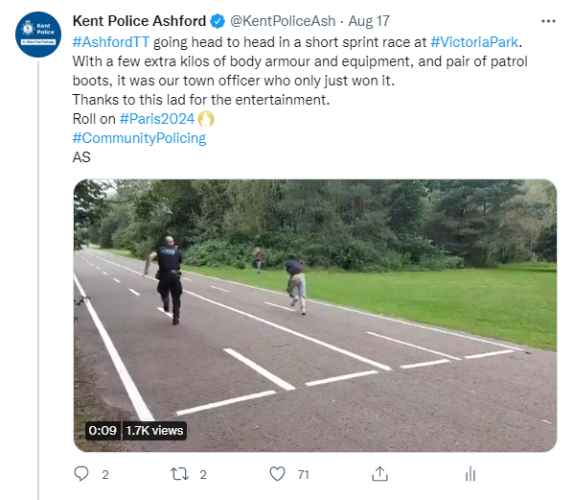

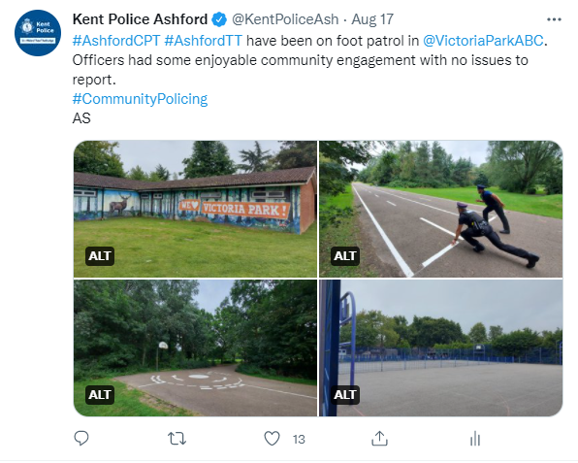

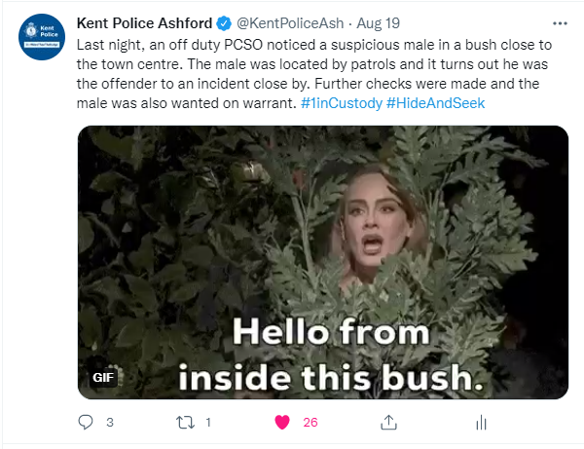

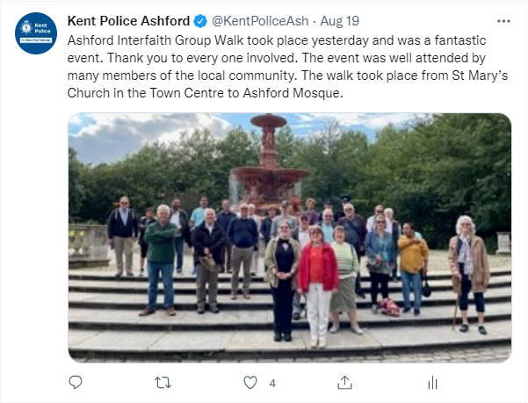

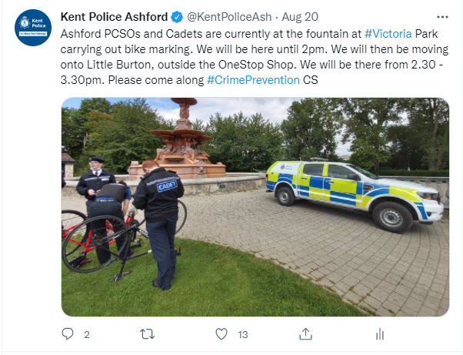

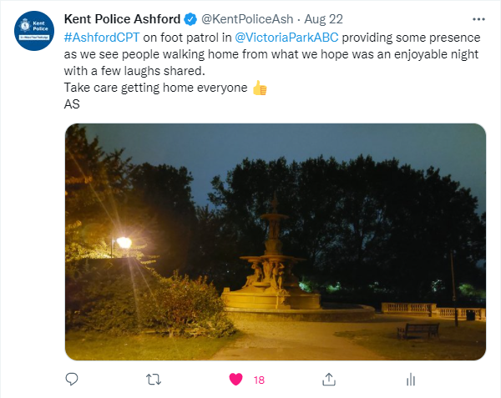

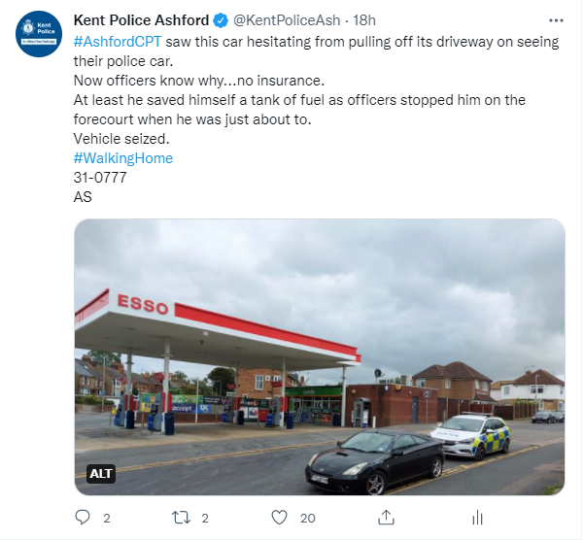

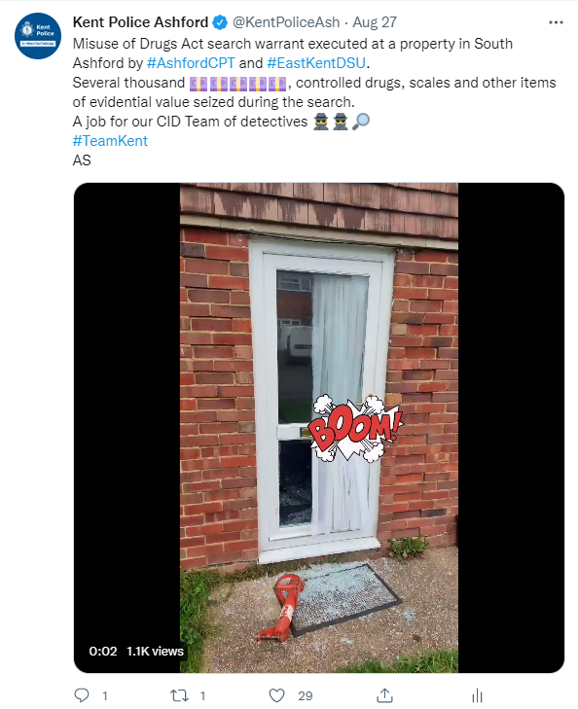

**Drug driving targeted in national campaign**

Motorists are being urged to drive safely as part of a national campaign targeting those who take the risk of driving whilst under the influence of drugs.  
  
From the Monday 23rd to Sunday 29th August 2021 officers from Kent Police will be out in force across the county, working with our partners to follow an intelligence led approach to target those who recklessly drug drive.  
  
They will be proactively patrolling and targeting high risk locations to identify and prosecute motorists who are impaired by drugs.  
  
Officers will be carrying out roadside drug wipes and field impairment tests at all times during the day and night to ensure those who break the law are arrested, charged and put before the courts.  
  
Drug driving is recognised nationally as one of the four main causes of death or serious injury on the roads.  These main factors are also known as the ‘Fatal 4’. When driving under the influence of drugs you can impair your awareness, judgement and reaction times and put yourself and other road users at risk.  
  
Chief Inspector Elena Hall from Kent Police’s Roads Policing Unit said: ‘The impact of drug driving can be devastating and our officers are committed to keeping the roads across Kent safe.  
  
‘Drivers need to remember they are not only risking their own life, but the lives of their passengers as well as other innocent motorists or pedestrians.

‘If you are caught drug driving you could face prison time, an unlimited fine and a driving ban. There is no excuse for driving under the influence of illegal substances.’  
  
Officers will be working closely with both Kent County Council and Medway Council throughout this week of action.  
  
Kent County Council’s Cabinet Member for Highways and Transport, David Brazier, said: ‘Taking drugs and driving can have serious consequences, apart from the fact it is illegal.  
  
‘Being under the influence of substances can cause blurred vision, erratic and aggressive behaviour, nausea, hallucinations, panic attacks, paranoia, shakes, dizziness and fatigue.  
  
‘I would urge everyone to think about how they might be able to react in an emergency and understand what is going on around them.’  
  
Cllr Phil Filmer, Medway Council’s Portfolio Holder for Frontline Services, said: ‘There is never an excuse for driving under the influence of any substance. Not only is drug-driving illegal it’s incredibly dangerous and can have a devastating impact on people’s lives. I would encourage residents to act responsibly and help reduce the number of incidents on our roads.’

Below is advice from our Crime Prevention Advice Officer

This month I will tailor the advice to **residential burglaries**:

* Keep keys and valuables out of sight, away from doors and windows – but know where they are in case of emergency
* Watch out for bogus callers and always ask for identification if an unexpected caller comes to your home. If you are unsure, don’t let them in and report it to the police straight away
* Lock sheds and garages and put away tools and equipment after use
* Security mark valuable items using a UV pen or forensic solution
* Consider installing a burglar alarm, if you don’t already have one

Facts supplied by Police.uk:

* Burglars target homes that they think will contain valuables. A giveaway is leaving packaging from expensive items outside your door
* Burglars often look for homes with windows or doors left open or with vulnerable features that they can exploit
* Burglars are aware of the times when someone is expected to be away from their house such as during the school run or holidays
* Burglars typically do not want to be seen or heard and if they feel that they would be noticed by a neighbour or passer-by then they are more likely to feel exposed and may move on to find somewhere else to burgle
* Burglars often choose a home because they’ve spotted a specific vehicle, motorcycle or bicycle they want to steal – and the keys are more than likely to be inside the residence
* [Sheds and garages](https://eur03.safelinks.protection.outlook.com/?url=https%3A%2F%2Fwww.police.uk%2Fcp%2Fcrime-prevention%2Fprotect-home-crime%2Fsecure-shed-garage%2F&data=04%7C01%7CNicola.Potter%40kent.police.uk%7C439f3edc56f64867c77108d9622e5ae4%7Cf31b07f09cf940db964d6ff986a97e3d%7C0%7C0%7C637648773491537871%7CUnknown%7CTWFpbGZsb3d8eyJWIjoiMC4wLjAwMDAiLCJQIjoiV2luMzIiLCJBTiI6Ik1haWwiLCJXVCI6Mn0%3D%7C1000&sdata=yB1lgIP4wOEiVvG4wudmdLWQpqlP6xUJZ5wITEObYzY%3D&reserved=0) are often vulnerable as they are not that secure and contain tools which the burglar can use to assist them to gain entry to a home

It may be useful to consider looking at the home security checklist below:

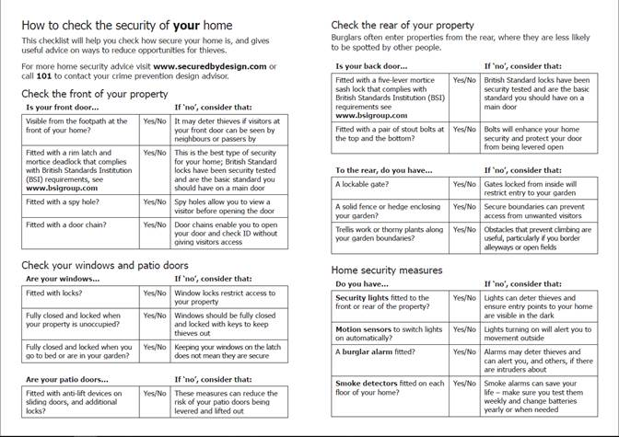

Please see [www.securedbydesign.com](https://eur03.safelinks.protection.outlook.com/?url=http%3A%2F%2Fwww.securedbydesign.com%2F&data=04%7C01%7CNicola.Potter%40kent.police.uk%7C439f3edc56f64867c77108d9622e5ae4%7Cf31b07f09cf940db964d6ff986a97e3d%7C0%7C0%7C637648773491542858%7CUnknown%7CTWFpbGZsb3d8eyJWIjoiMC4wLjAwMDAiLCJQIjoiV2luMzIiLCJBTiI6Ik1haWwiLCJXVCI6Mn0%3D%7C1000&sdata=K30%2FSdHRGendDFc29KAuJpC2je0nEfhDcyBF4G5VOfo%3D&reserved=0) for more ways improve the security of buildings and their immediate surroundings. Secured by Design’s (SBD’s) product based accreditation scheme – the Police Preferred Specification - provides a recognised standard for all security products that can deter and reduce crime.

We have seen a rise in the reporting of dog thefts not only in the Ashford district but across the UK. Below is some guidance in relation to keeping your dog safe when out and about.

I have also included below several helpful posters from the Kent fraud alert system which are worth taking the time to read.

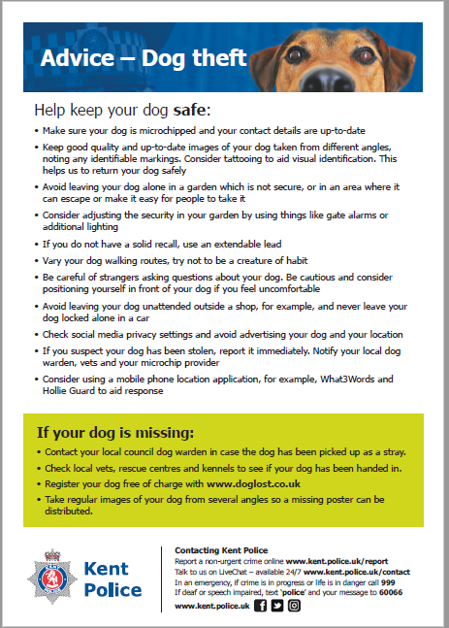

**Police do not monitor community Facebook, Twitter, neighbour next door apps etc...and these are not the correct way to report things going on, otherwise we are unaware and unable to help you in your community.**

**I hope you have found this newsletter interesting. Please feel free to share it with others**

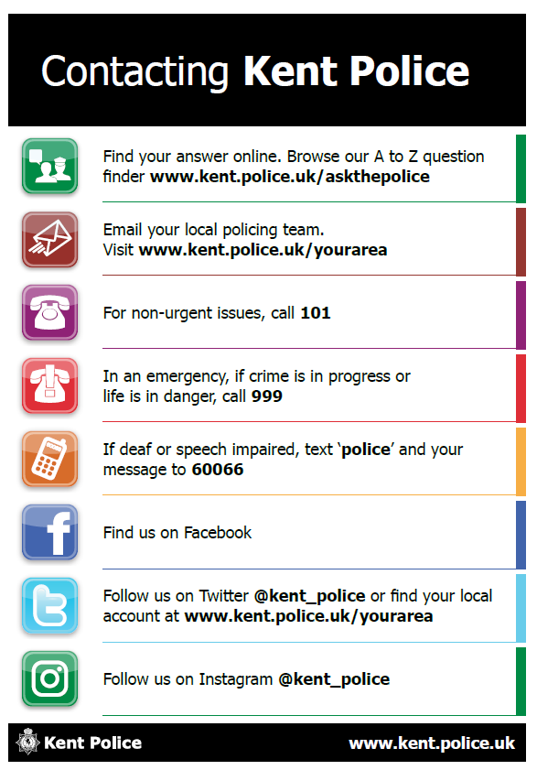



**PCSO 57348 WELCH**

**Community Safety Unit**

**Ashford Police Station**